<https://github.com/jyou338/Hello-Unity/tree/master/Lab%20test%202>

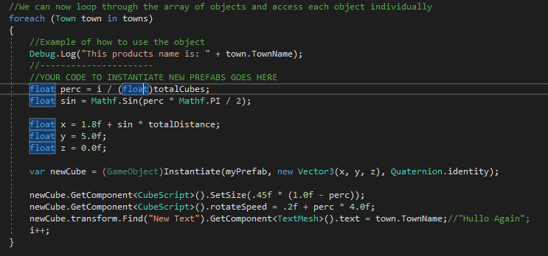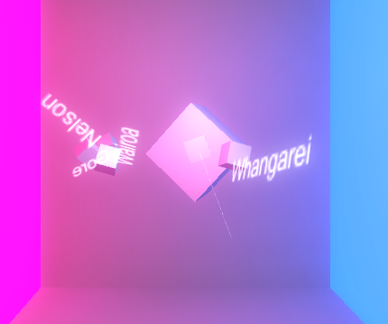1 and 2.

Created new town object to deserialize response and changed the text to use the town name

3.

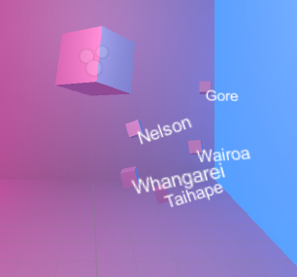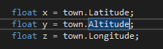

Changed the x,y,z values that are used to create the Vector3 when instantiating the cube

4.

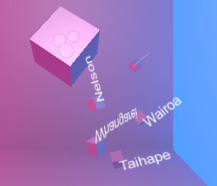

Stopped them spinning by setting rotateSpeed to 0.

  
Set the size to town.Size \* 0.3f as the cubes were too large when setting it to just town.Size.

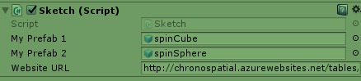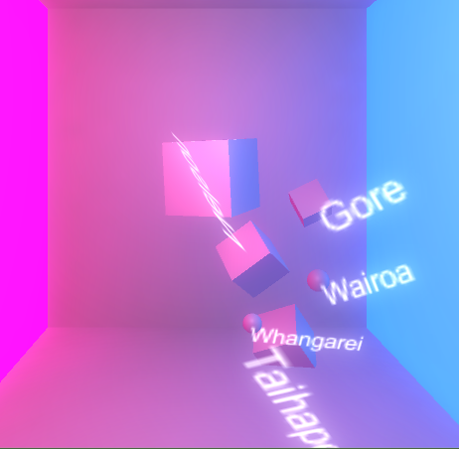

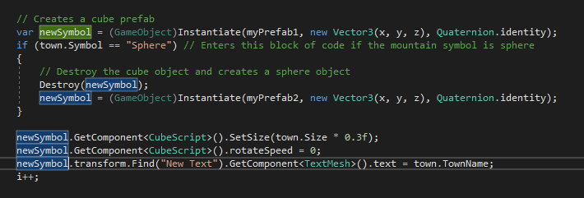

Created a new prefab called spinSphere and attached the cubeScript to it.

Added another public field so we can add 2 different prefabs.

Create a prefab1 (spinCube) first, if the Symbol field is Sphere, then destroy the prefab1 and instantiate a prefab2 (spinSphere).

5.

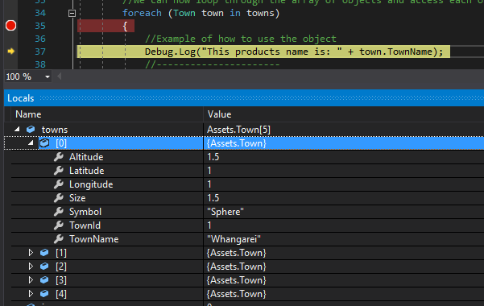

6.

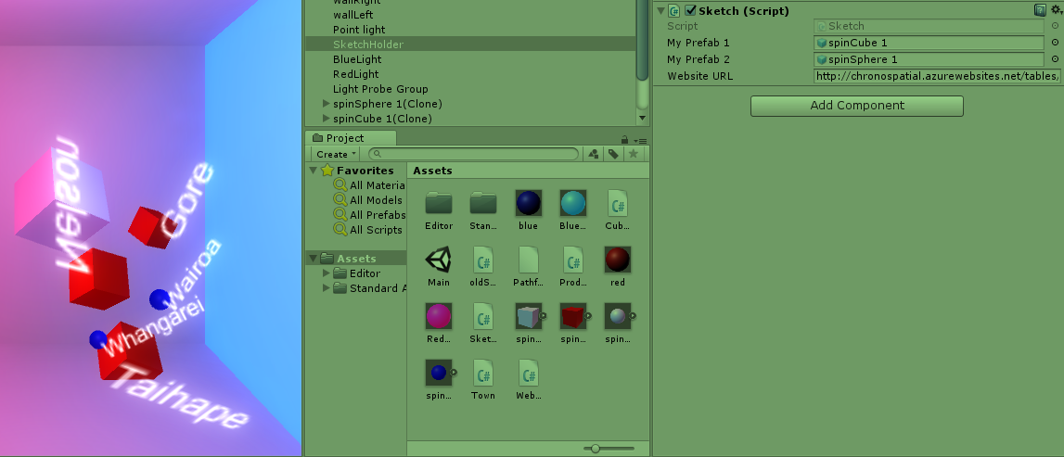

Create a red and blue material and attached each to a cube and sphere. Created new prefabs and assigned them to the sketch script